Mirzo Ulug‘bek nomidagi O‘zbekiston milliy universitetining Jizzax filiali Amaliy matematika fakulteti Axborot xavfsizligi yo’nalishi 481-22-guruh talabasi Sodiqov Diyorbekning Sun'iy intellekt va neyronto'rli texnologiya fanidan bajargan fan topshirig’i.

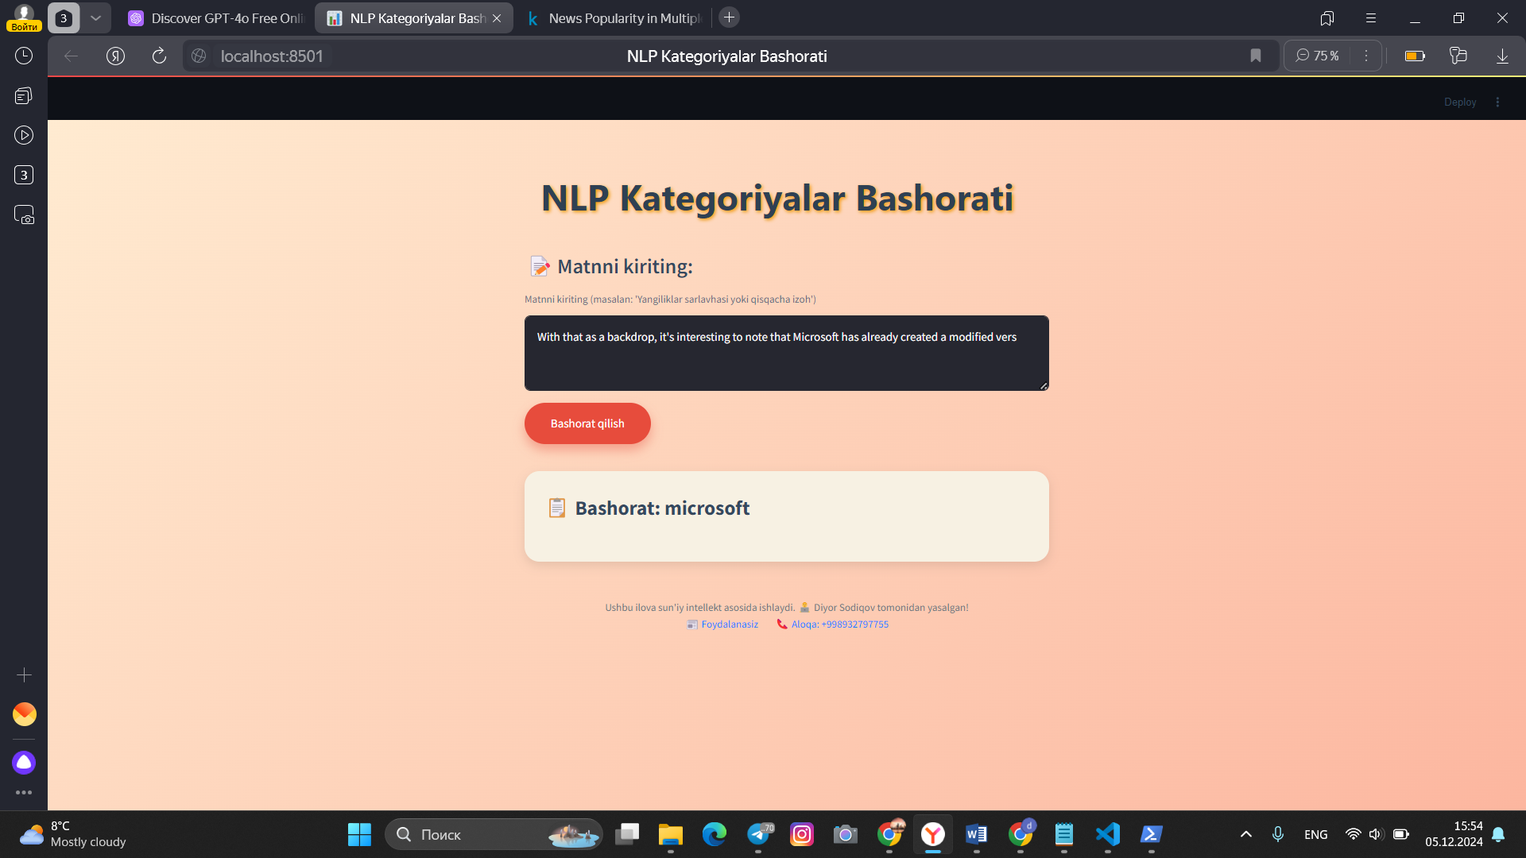

Vs code dasturi :

import streamlit as st

import pickle

*# Set the page configuration first*

st.set_page_config(page_title="NLP Kategoriyalar Bashorati", page_icon="📊", layout="centered")

*# Modelni yuklash*

@st.cache_resource

def load_model():

    with open('nlp_model.pkl', 'rb') as model_file:

        model = pickle.load(model_file)

    with open('tfidf_vectorizer.pkl', 'rb') as vectorizer_file:

        vectorizer = pickle.load(vectorizer_file)

    return model, vectorizer

model, tfidf = load_model()

*# Streamlit interfeysi sozlash*

st.markdown(

    """

    <style>

    /* Umumiy fon uchun rangli gradient */

    .stApp {

        background: linear-gradient(135deg, #ffecd2, #fcb69f);

        color: #34495E;

        font-family: 'Arial', sans-serif;

    }

    /* Karta uchun quti ko'rinishi */

    .main {

        background-color: #ffffff;

        padding: 30px;

        border-radius: 25px;

        box-shadow: 0px 15px 30px rgba(0, 0, 0, 0.2);

        max-width: 750px;

        margin: 20px auto;

        border: 2px solid #f39c12;

    }

    /* Sarlavha */

    h1 {

        color: #2E4053;

        text-align: center;

        font-family: 'Segoe UI', Tahoma, Geneva, Verdana, sans-serif;

        font-size: 3rem;

        font-weight: bold;

        margin-bottom: 25px;

        text-shadow: 2px 2px 5px #f39c12;

    }

    /* Matn maydoni sarlavhasi */

    .stTextArea>label {

        font-size: 1.3rem;

        color: #5D6D7E;

        font-weight: bold;

        margin-bottom: 10px;

    }

    /* Tugmalar */

    .stButton>button {

        background-color: #e74c3c !important;

        color: #ffffff !important;

        border-radius: 50px !important;

        padding: 15px 35px !important;

        font-size: 20px !important;

        font-weight: bold;

        border: none;

        box-shadow: 0px 8px 15px rgba(231, 76, 60, 0.4);

        transition: 0.3s ease;

    }

    .stButton>button:hover {

        background-color: #c0392b !important;

        box-shadow: 0px 12px 20px rgba(192, 57, 43, 0.4);

        transform: scale(1.05);

    }

    /* Natijalar qutisi */

    .result-section {

        background-color: #f7f1e3;

        padding: 25px;

        border-radius: 20px;

        margin-top: 20px;

        box-shadow: 0px 5px 15px rgba(0, 0, 0, 0.1);

    }

    .result-section h3 {

        font-size: 1.7rem;

        color: #34495E;

        font-weight: bold;

        margin-bottom: 15px;

    }

    .result-section p {

        font-size: 1.2rem;

        color: #2c3e50;

        margin-bottom: 10px;

    }

    /* Ikonalar */

    .icon {

        font-size: 1.8rem;

        margin-right: 10px;

        color: #2980b9;

    }

    /* Footer */

    .footer {

        text-align: center;

        margin-top: 50px;

        font-size: 14px;

        color: #6c757d;

    }

    /* Footer havolalar */

    .footer a {

        color: #007bff;

        text-decoration: none;

        margin: 0 10px;

    }

    .footer a:hover {

        text-decoration: underline;

    }

    </style>

    """,

    unsafe_allow_html=True

)

*# Sarlavha*

st.title("NLP Kategoriyalar Bashorati")

*# Matnni kiriting*

st.markdown("<h3 style='color:#34495E;'>📝 Matnni kiriting:</h3>", unsafe_allow_html=True)

user_input = st.text_area(

    "Matnni kiriting (masalan: 'Yangiliklar sarlavhasi yoki qisqacha izoh')",

    "",

    placeholder="Matnni bu yerga yozing..."

)

*# Bashorat qilish*

if st.button("Bashorat qilish"):

    if user_input.strip():

*# Matnni vektorizatsiya qilish*

        input_vectorized = tfidf.transform([user_input])

*# Model orqali bashorat qilish*

        prediction = model.predict(input_vectorized)

*# Natijani ko'rsatish*

        st.markdown(

            f"<div class='result-section'><h3>📋 Bashorat: {prediction[0]}</h3></div>",

            unsafe_allow_html=True,

        )

    else:

        st.error("Iltimos, matn kiriting!")

*# Footer*

st.markdown(

    """

    <div class='footer'>

        Ushbu ilova sun'iy intellekt asosida ishlaydi. 👨‍💻 Diyor Sodiqov tomonidan yasalgan!<br>

        <a href='https://www.kaggle.com/datasets/nikhiljohnk/news-popularity-in-multiple-social-media-platforms' target='_blank'>

            📰 Foydalanasiz

        </a>

        <a href='tel:+998932797755'>

            📞 Aloqa: +998932797755

        </a>

    </div>

    """,

    unsafe_allow_html=True,

)

Colabda dasturi :

# 1. Google Colabda boshlang'ich ishlar

from google.colab import files

import pandas as pd

# Datasetni yuklash

uploaded = files.upload()

# CSV faylni o'qish

data = pd.read_csv(next(iter(uploaded)))

# Datasetning boshini ko'rish

print("Datasetning birinchi qatorlari:")

print(data.head())

# 2. Ma'lumotlarni tozalash va tayyorlash

# Faqat kerakli ustunlarni tanlab olish

data = data[['Title', 'Headline', 'Topic']] # Faqat kerakli ustunlar

data.dropna(inplace=True) # Bo'sh qiymatlarni olib tashlash

# NLP ishlov berish uchun "Headline" yoki "Title" ustunidan foydalanamiz

from sklearn.model_selection import train_test_split

from sklearn.feature_extraction.text import TfidfVectorizer

# Matnni vektorizatsiya qilish uchun TfidfVectorizer

tfidf = TfidfVectorizer(stop_words='english', max_features=5000)

# Matnlarni vektorizatsiya qilish

X = tfidf.fit_transform(data['Headline']) # Yoki 'Title' tanlang

y = data['Topic'] # Maqsadli ustun

# Train-test ma'lumotlarini ajratish

X_train, X_test, y_train, y_test = train_test_split(X, y, test_size=0.2, random_state=42)

# 3. Modelni qurish va o'qitish

# Logistic Regression modeli

from sklearn.linear_model import LogisticRegression

from sklearn.metrics import classification_report, accuracy_score

# Modelni yaratish va o'qitish

model = LogisticRegression(max_iter=1000)

model.fit(X_train, y_train)

# Test ma'lumotlarida bashorat qilish

y_pred = model.predict(X_test)

# Modelni baholash

print("\nClassification Report:")

print(classification_report(y_test, y_pred))

print("Aniqlik darajasi:", accuracy_score(y_test, y_pred))

# 4. Modelni saqlash

import pickle

# Modelni saqlash

model_filename = 'nlp_model.pkl'

with open(model_filename, 'wb') as file:

pickle.dump(model, file)

# Vektorizatorni saqlash

vectorizer_filename = 'tfidf_vectorizer.pkl'

with open(vectorizer_filename, 'wb') as file:

pickle.dump(tfidf, file)

# Fayllarni yuklab olish

files.download(model_filename)

files.download(vectorizer_filename)

kaggledagi dataset linki:

https://www.kaggle.com/datasets/nikhiljohnk/news-popularity-in-multiple-social-media-platforms